Spring Boot Security
JASS: Java Authentication and Authorization.
- Implementing Login and Logout concept for our application.
Authentication: Validate user inputs (username, password)
- InMemoryAuthentication Store user details at RAM (temp)
- JdbcAuthentication Store user details at database
Ex: Works based on SQL internally.
- Custom UserDetailsService Store user details at database
Ex: Uses ORM concepts (Data JPA) internally.
Authorization: Validate User Role (Authority) to access any resource (PATH)
- permitAll : Url/path can be accessed by everyone (No security required)
Ex: /welcome, /index, /contactUs, /aboutUs …etc
- Authenticated: Url/path can be accessed by login users (can have any)
Ex: /myProfile, /settings, /logout …etc
- has Authority: Url/path can be accessed by login user with matching role
Ex: Sam (ADMIN) /viewEmployees
Ajay (CUSTOMER) /viewContracts

- Authorization/Authority says who can do what.
Ex: In bank application
SAM Manager Approve Loan /approveLoan
AJAY Customer View His balance -> /showBal
===Example===============================================================
- /findBranch everyone can use this service (no security required)
  - .antMatchers(“/findBranch”).permitAll()
- /login Everyone can access login (no security required)
  - .antMatchers(“/login”).permitAll()
- /profile Users can access only after login (Login first)
  - .antMatchers(“/findBranch”).authenticated()
- /changePwd User can access only after login (no role required)
  - .antMatchers(“/changePwd”). authenticated()
- /applyLeave After Login with Role Employee
  - .antMatchers(“/applyLeave”).hasAuthority(“Employee”)
- /approveLeave After Login with Role Manager
  - .antMatchers(“/approveLeave”).hasAuthority(“Manager”)
- Even Manager can apply for leave on behalf of Employee
  - .antMatchers(“/applyLeave”).hasAuthority(“Employee”,”Manager”)
- 10 URLs, in that 4 are configured using antMatchers, remaning (6 URLs) can be indicated using
  - .antMatchers(“/showA,”/find”).permitAll()
  - .antMactchers(“/viewData”,”/info”).hasAuthority(“Manager”)
  - .anyRequest().authenticated()

Security Implementation Steps:
- Add Dependency: Spring Security, thymeleaf-extras-springsecurity5
- Define one Security Configuration class with 2 Beans
  - 1st is for Authentication and 2nd is for Authorization.
Sample Code: Refer 01-SpringBootSecurityInMemoryEx
Spring Security Coding Points:
- Add Spring Security Dependency in pom.xml
[spring-boot-stater-security]
- Define one configuration class with 2 annotations added
  - @Configuration: It is a java config file (Method @Bean object)
  - @EnableWebSecurity: Activates Security Concepts (Login, Form validation, Session management, Logout Config)
- Define two beans (methods)
  - Authentication: To holds UserDetailsService(I)
    - InMemoryUserDetailsManager(Impl class)
      - Stores: Users, password, authority
  - Authorization:
    - To load URL Access Details (antMatchers)
    - Login Form Details
    - Logout Details
[above details can be hold using SecurityFilterChain(I)]
Impl class: DefaultSecurityFilterChain(c)
InMemoryUserDetailsManager:-
- This one is used to store user details inside RAM (temp memory)
- It is used only at Dev/Test Environments only.
Example:
User name Password Autority
sam sam admin
ram ram customer

- Password Encoder: It is recomanded to store password in database after encoding.
- We must specify any one passwordEncoder in application. Or elase speify default i.e withDefaultPasswordEncoder() i.e do nothing/no encoding.
Example:
public class Test {
public static void main(String[] args) {
BCryptPasswordEncoder bCryptPasswordEncoder = new BCryptPasswordEncoder();
String pwd = bCryptPasswordEncoder.encode("sam");
System.out.println(pwd);
}
}

- There is no decode() method.
Register Form Password Encoded compare with DB Data
JDBC Authentication:
- Store user details inside database as a table.
- Spring boot stater JDBC Dependency need to be added in project. [pom.xml]
- Spring boot 2.6.x we need to define queries manually for creating table, insert user, select users, etc...
- In latest version of spring boot queries are predefined for user operations (save/insert, select. Etc)
- BCryptPasswordEncoder is used to convert user password to unreadable format before storing in database.
create table users(
username varchar(50) not null primary key,
password varchar(500) not null,enabled boolean not null);
create table authorities (
username varchar(50) not null,
authority varchar(50) not null,constraint fk_authorities_users foreign key(username) references users(username));
create unique index ix_auth_username on authorities (username,authority);

@Configuration
@EnableWebSecurity
public class SecurityConfig {

@Bean
public BCryptPasswordEncoder passwordEncoder() {
return new BCryptPasswordEncoder();
}

// ========= Authentication =========
@Bean
public UserDetailsService configAutentication(DataSource dataSource) {

UserDetails user1 = User.withUsername("sam")
.password("$2a$10$e.K89JD8U96rGlP5Kro6Pe/pfyawPAEqkh3sn9CDWlSSxEIZladou").authorities("ADMIN").build();
UserDetails user2 = User.withUsername("ram")
.password("$2a$10$qKZ8raOkNyQdVE1kr6xpRuAaczeAuR6DjUHa/7.kfeXyifHVUMlSm").authorities("CUSTOMER")
.build();

JdbcUserDetailsManager users = new JdbcUserDetailsManager(dataSource);

if (!users.userExists(user1.getUsername())) {
users.createUser(user1);
}
if (!users.userExists(user2.getUsername())) {
users.createUser(user2);
}

return users;
}

// ========= Authorization ==========
@Bean
public SecurityFilterChain configAuthorization(HttpSecurity http) {
http.authorizeHttpRequests(request -> request.requestMatchers("/", "/home").permitAll()
.requestMatchers("/admin").hasAuthority("ADMIN").requestMatchers("/customer").hasAuthority("CUSTOMER")
.anyRequest().authenticated())
.formLogin(form -> form.loginPage("/login").permitAll().defaultSuccessUrl("/hello", true))
.logout(logout -> logout.permitAll());
return http.build();
}
}

Spring boot security using ORM:
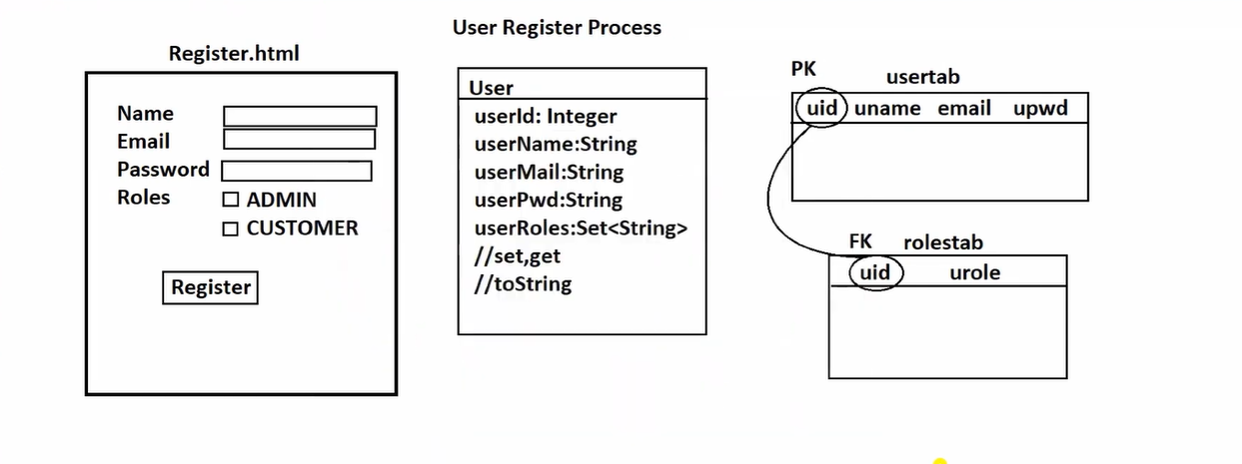
- User register process: Create an html form to store user data in database.
- Password encoder & user login/logout: Convert readable format to unreadable format (i.e., encode) Security configuration for Login/Logout.
- User Register Process:
  - Entity
  - Repository
  - Service
  - Controller
  - UI pages
  - Properties file
- Dependency: Spring web, Lombok, Devtools, Data jpa, MySql
Q) Can we define two classes with same name in java?
Ans: Yes, it is possible. But they must exits in different package.
Package com.app
Class A{}

Package one.test
Class A{}
Ex: Date class with java.util and java.sql package.
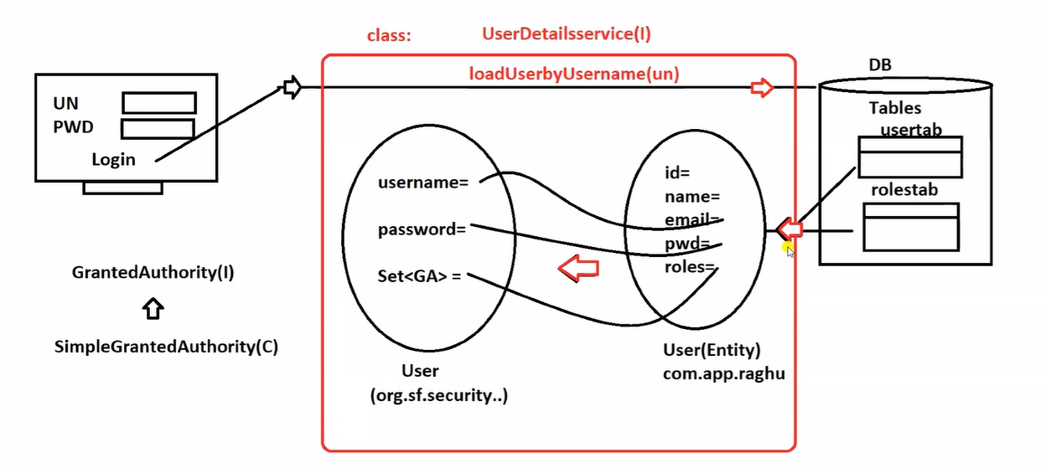

- We have create one class User(tech.csm), which holds Register form data and store with database.
- Spring security has given class name : User(org.sf.security.core.userdetails), which is implements one UserDetails(I) which holds data for login operations.
- We need to define one class that implemets UserDetailsService(I) and override the method loadUserbyUsername(username). That reads data from DB as Entity class User object and converts into spring security user object.
- We call in general as Role. But in coding it is : Authority.
- GrantedAuthority(I) : Allocated Roles to a user
- Ex: App#1 : Roles: ADMIN, CUSTOMER, MANAGER, SALES, SERVICE, TEST
- User#1 : SAM, Allocated Roles: SALES, SERVICE
  - i.e called as SAM has 2 GrantedAuthorities
- SImpleGrantedAuthority(C) is a class that implemets GrantedAuthority(I), which is String role only intenally.
- LazyInitializationException: failed to lazily initialize a collection of role could not initialize proxy - no session.
  - Use : FetchType.EAGER at Collection Mapping
- Security config with DaoAuthenticationManger(UserDetailsManager,PasswordEncoder) and SecurityFilterChain
Ctrl+shift+T : SecurityContextLogoutHandler
Spring Security internlly uses Servlet concept. i.e. HttpServletRequest, ServletContext ..etc

Session Management in Servlet:
For every user, storing user data at server for a period of time (login to logout) in key=val format (String=Object) called as Session Management/State Management.
- Create a new session
  - HttpSession session = request.getSession(true);
- Read existed session
  - HttpSession session = request.getSession(false);
- Add/modify our data to session
  - session.setAttribute(“uname”,”AKSHAY”);
  - session.setAttribute(“uname”,”SAMPLE”);
- Remove our data from Session
  - String s = (String) session.getAttribute(“uname”);
- Delete Session on logout
  - session.invalidate()
- Read username with spring security concept.
[java.security] : Given by Sun/Oracle to all Security Framework by saying that it must be created and stored with username
Principal(I)
getName():String
IS-A
[org.springframeworksecurity.authentication] : Given by spring security, storing uname + roles
Authentication(I)
name + GrantedAuthorities
IS-A
[org.springframework.security.authentication]
UsernamePasswordAuthenticationToken(C)
- Showing Session timeout
  - Session.setMaxInactiveInterval(60*15); //timeout after 15 mins

Issues of using – Session Management at server side:
- As no. of objects crated at server, it needs more space/RAM/Disk and burden to server.
Now a days token-based authentication is used at server (i.e. called as Stateless, no HttpSession) and user data is stored at browser/client device – Angular ngrx/ReactJS Redux. Sensitive information is stored at server side as a cache/DB.

Token Based Authentication
Token is created when is user is logged in by server(application). Same token is sent to client application using response body. For every request client machine has to send request with token as Header Param, if not server app considers is logged out.
We can create a new token with expDate/Time Zero and sent to client as new token for logout.

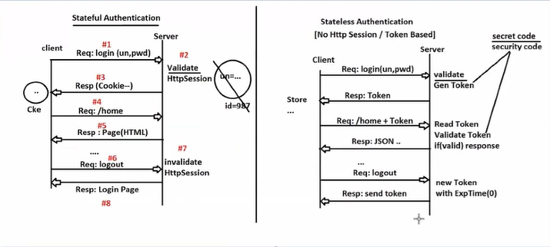

JWT (Json Web Token)
- Open-Source API used to implement token based Authentication.
- JWT Token = Header.Payload.Singnature (Encoded Format)
- To generate the token, To validate Token, we must use one secret key.
- JWT supports multiple languages like Java, .net, ...etc.
For token coding, add below dependency: -
<dependency>
<groupId>io.jsonwebtoken</groupId>
<artifactId>jjwt</artifactId>
<version>0.13.0</version>
</dependency>

Sample token model: xxxxxxxxxxxxxxxxxxxx.yyyyyyyyyyyyyyyyyyy.zzzzzzzzzzzzzzzzzzz

Header: Encoded Form (JWT Information, Version, Algo type, ...etc)
Payload: Encoded Form (id, subject, issuedAt, issuer, expDate, …etc)
Signature: Encoded From (Header + Payload+ Sign Algo + Secret Key)
- Secret key must not be shared with anyone.
- Must exist at server side only.
- If Secret key is given, they can read token data.

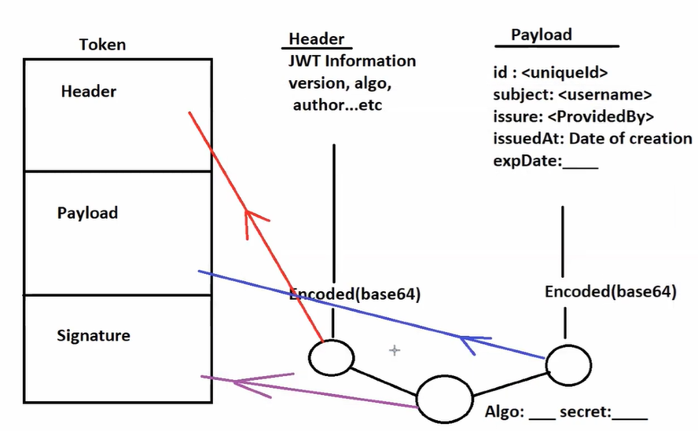
Basic coding:
Maven Application:
Pom.xml:
<project xmlns="http://maven.apache.org/POM/4.0.0"
xmlns:xsi="http://www.w3.org/2001/XMLSchema-instance"
xsi:schemaLocation="http://maven.apache.org/POM/4.0.0 https://maven.apache.org/xsd/maven-4.0.0.xsd">
<modelVersion>4.0.0</modelVersion>
<groupId>tech.csm</groupId>
<artifactId>JwtAuthEx</artifactId>
<version>1.0</version>
<properties>
<maven.compiler.source>8</maven.compiler.source>
<maven.compiler.target>8</maven.compiler.target>
</properties>
<dependencies>
<dependency>
<groupId>io.jsonwebtoken</groupId>
<artifactId>jjwt</artifactId>
<version>0.13.0</version>
</dependency>
<dependency>
<groupId>javax.xml.bind</groupId>
<artifactId>jaxb-api</artifactId>
<version>2.3.1</version>
</dependency>
</dependencies>
</project>

Test Class:
package tech.csm;

import java.util.Date;
import java.util.concurrent.TimeUnit;

import io.jsonwebtoken.Claims;
import io.jsonwebtoken.Jwts;
import io.jsonwebtoken.SignatureAlgorithm;

public class Test {
public static void main(String[] args) {

final String SECRET_KEY = "hvndflhkfjhgfvdfsjklvhjdfsvhjfvdfhvbd";

String token = Jwts.builder().setId("001").setSubject("Akshaykirti Muduli").setIssuer("CSM")
.setIssuedAt(new Date(System.currentTimeMillis()))
.setExpiration(new Date(System.currentTimeMillis() + TimeUnit.MINUTES.toMillis(5)))
.signWith(SignatureAlgorithm.HS256, SECRET_KEY.getBytes()).compact();

System.out.println(token);

Claims claims = Jwts.parser().setSigningKey(SECRET_KEY.getBytes()).build().parseClaimsJws(token).getBody();

System.out.println("Subject: " + claims.getSubject());
System.out.println("id: " + claims.getId());
System.out.println("Issuer: " + claims.getIssuer());
}
}

Spring Boot Token Based Authentication using JJWT
- Payload classes: To get User request data as JSON convert into Object format (same for response)
- User Response: It contains JWT Token data and some notes on login success.
- Entity: To map a class with DB and store user data.
- Repository: To perform database operation for User.
- Service: Implement service for operations like save, find user, encode before save... convert Entity to Spring Security user.
- Implement UserDetailsService (I) and override loadUserByusername() method.
- JwtUtil: This class get details at runtime to generate or validate token.
Add below dependency manually:
<dependency>
<groupId>io.jsonwebtoken</groupId>
<artifactId>jjwt</artifactId>
<version>0.13.0</version>
</dependency>

- RestController: This controller class is used to register user; login check and provide other resources.
- Define AppConfig for passwordEncoder bean.
- AuthenticationEnrtyPoint for indicating login failed.
- Define one Security Filter that validates user details based on Authorization Header and JwtUtil.

